TIGER AI ULTIMATE v3.0
Fused Multi-Source Pipeline -- Sample Output Report

EPAIB Batch 05 | Group 4 | IIM Lucknow
Generated: 10 June 2026 21:39

Dataset covered in this report:
Test Data 4 (Amur Tiger Camera Trap -- 20 images, 000081-000147)
Cumulative DB loaded from prior runs (Tiger_001 - Tiger_011 from Test Data 3)

────────────────────────────────────────────────────────────────────────────────

1. Project Overview
This report documents the end-to-end output of the Tiger AI Ultimate v3.0 pipeline run on Test Data 4 -- 20 camera-trap images of Amur (Siberian) tigers. The pipeline was developed by Group 4 as part of the EPAIB Batch 05 capstone project at IIM Lucknow. It performs automated tiger detection, species verification, individual fingerprinting, cross-dataset re-identification, and census estimation from raw camera-trap images, requiring zero manual labelling.
1.1 Pipeline Architecture (v3.0 Fused)
Component | Technology | Source
Stage 1 Detection | YOLOv8l-OIV7 (Open Images V7 -- direct Tiger class) | OIV7 model
Stage 2 Detection | YOLOv8l-COCO (cat/dog/horse/zebra proxy classes) | COCO model
Stage 3 Fallback | Whole-image scan if both YOLOs find nothing | v3.0 pipeline
Species Gate | ResNet50 top-3/top-5 must contain 'tiger' | ResNet50 ImageNet
Dark Image Fix | Gamma correction + strong CLAHE for dark crops | v3.0 (new)
IR Night Fix | IR check runs BEFORE brightness check in triage | v3.0 (new)
ViewPoint Label | Left_Flank / Right_Flank / Frontal classification | Orientation model
Feature Extraction | ResNet50 2048-dim avg_pool stripe fingerprint | ResNet50 layer
Identity Matching | Cosine similarity >= 0.83, running-average DB | Cosine sim
DB Persistence | Cumulative JSON DB -- fingerprints carry across runs | v2 upgrade
Preprocessing | CLAHE + Dark Channel Prior + IR normalisation | OpenCV pipeline
Guards | Fence detection / Vertical-body / Overlap IoU checks | v3.0 safety
Explainability | Grad-CAM on ResNet50 layer4 (--gradcam flag) | Grad-CAM

1.2 Why Each Model Was Chosen
Model | Role | Why Chosen | Alternative Considered
YOLOv8l + OIV7 | Tiger detection | Open Images V7 has direct Tiger class | MegaDetector (complex install)
YOLOv8l + COCO | Backup detection | Standard benchmark; cat/dog/zebra as proxies | Nothing (COCO is standard)
ResNet50 | Species gate + ID | ImageNet-1K includes tiger; fast transfer | EfficientNetV2-L (wrong class map)
Cosine similarity | Identity matching | Scale-invariant; handles brightness changes | Euclidean (brightness-sensitive)
Running average | Fingerprint refine | Each sighting improves the DB profile | Fixed embedding from first shot
CLAHE | Contrast enhance | Recovers stripe detail in shadow/dawn images | Global histogram eq (too harsh)
Grad-CAM | Explainability | Visual proof model reads stripes not background | LIME (slower for images)

2. Test Data 4 -- Amur Tiger Camera Trap (20 Images)
Test Data 4 contains 20 camera-trap images of Amur (Siberian) tigers (files 000081-000147). The pipeline loaded the existing cumulative identity database (11 known tiger profiles built from prior Test Data runs) and performed cross-dataset re-identification alongside new tiger enrollment. No retraining was performed between datasets.
2.1 Run Summary
Metric | Value
Dataset path | Amur Tigers / Test Data 4
Total images processed | 20
Images with tigers found | 19 (95.0%)
Images with no tiger | 1 (5.0%) -- 000123.jpg (IR Night, species gate rejected)
Unusable / skipped images | 0
Total tiger detections | 21
New tigers enrolled | 5 (Tiger_012, Tiger_013, Tiger_014, Tiger_015, Tiger_016)
Cross-dataset re-IDs | Tiger_001 (11 sightings), Tiger_005, Tiger_006, Tiger_011
Unique IDs in DB (total) | 16 (11 prior + 5 new)
Conservative census | 7 (max of Left/Right/Frontal viewpoint counts)
Liberal census | 9 (union of all unique IDs seen in this run)
Run device | CPU
Run date | 10 June 2026

2.2 Image Quality Breakdown
Category | Count | % of Total | Notes
Clean -- processable | 19 | 95.0% | Passed all quality checks
IR / Night | 1 | 5.0% | 000123.jpg -- near-identical RGB channels; species gate returned no tiger
Unusable -- Blurry | 0 | 0% | All images passed blur threshold (v2 combined metric)
Unusable -- Underexposed | 0 | 0% | No heavily underexposed images
Unusable -- Overexposed | 0 | 0% | No blown-out images

2.3 Cascade Detection Performance
Detection Stage | Detections | % of Total | Observation
Stage 1: OIV7 Direct Tiger | 16 | 76.2% | Tiger class detected directly -- no proxy needed
Stage 2: COCO Proxy | 3 | 14.3% | cat/dog/zebra proxy triggered; ResNet gate confirmed
Stage 3: Whole-Image Fallback | 1 | 4.8% | 000081.jpg -- YOLO missed; fallback + grid scan found 1 tiger
Low-Conf OIV7 (0.08) | 1 | 4.8% | 000143.jpg -- second tiger at corner (score 0.08), new enrollment

2.4 Per-Image Detection Results
Each image was processed through the full cascade: triage -> preprocessing -> YOLOv8 detection -> species verification -> fingerprint matching -> identity DB update. Annotated output images are saved in reports/v2_annotated/.
Image | Quality | Tiger? | Count | Tiger ID(s) | Detection Stage | Visibility | Confidence
000081.jpg | Clean | YES | 1 | Tiger_012 | Whole_Image_Fallback | Full_Body | MEDIUM
000082.jpg | Clean | YES | 2 | Tiger_001, Tiger_011 | OIV7_Direct | Corner_Trace | HIGH / MED
000084.jpg | Clean | YES | 1 | Tiger_001 | OIV7_Direct | Corner_Trace | MEDIUM
000088.jpg | Clean | YES | 1 | Tiger_001 | OIV7_Direct | Corner_Trace | HIGH
000099.jpg | Clean | YES | 1 | Tiger_001 | OIV7_Direct | Corner_Trace | HIGH
000101.jpg | Clean | YES | 1 | Tiger_006 | COCO_Proxy | Corner_Trace | MEDIUM
000102.jpg | Clean | YES | 1 | Tiger_001 | OIV7_Direct | Corner_Trace | HIGH
000106.jpg | Clean | YES | 1 | Tiger_001 | OIV7_Direct | Corner_Trace | MEDIUM
000110.jpg | Clean | YES | 1 | Tiger_001 | OIV7_Direct | Corner_Trace | HIGH
000114.jpg | Clean | YES | 1 | Tiger_001 | OIV7_Direct | Corner_Trace | MEDIUM
000119.jpg | Clean | YES | 1 | Tiger_001 | COCO_Proxy | Corner_Trace | MEDIUM
000123.jpg | IR_Night | NO | 0 | -- | COCO_Proxy (rejected) | -- | REJECTED
000124.jpg | Clean | YES | 1 | Tiger_001 | OIV7_Direct | Corner_Trace | MEDIUM
000128.jpg | Clean | YES | 1 | Tiger_013 | OIV7_Direct | Full_Body | MEDIUM
000130.jpg | Clean | YES | 1 | Tiger_014 | OIV7_Direct | Full_Body | MEDIUM
000132.jpg | Clean | YES | 1 | Tiger_001 | COCO_Proxy | Corner_Trace | MEDIUM
000139.jpg | Clean | YES | 1 | Tiger_001 | OIV7_Direct | Corner_Trace | HIGH
000143.jpg | Clean | YES | 2 | Tiger_001, Tiger_015 | OIV7_Direct + LowConf | Full_Body + Partial | HIGH / MED
000145.jpg | Clean | YES | 1 | Tiger_005 | OIV7_Direct | Corner_Trace | MEDIUM
000147.jpg | Clean | YES | 1 | Tiger_016 | OIV7_Direct | Full_Body | MEDIUM

2.5 Sample Annotated Images
Below are annotated output images generated by the pipeline for selected frames. Bounding boxes show tiger detections; colour indicates morph type (orange/golden/black). All 20 annotated images are saved in reports/v2_annotated/.
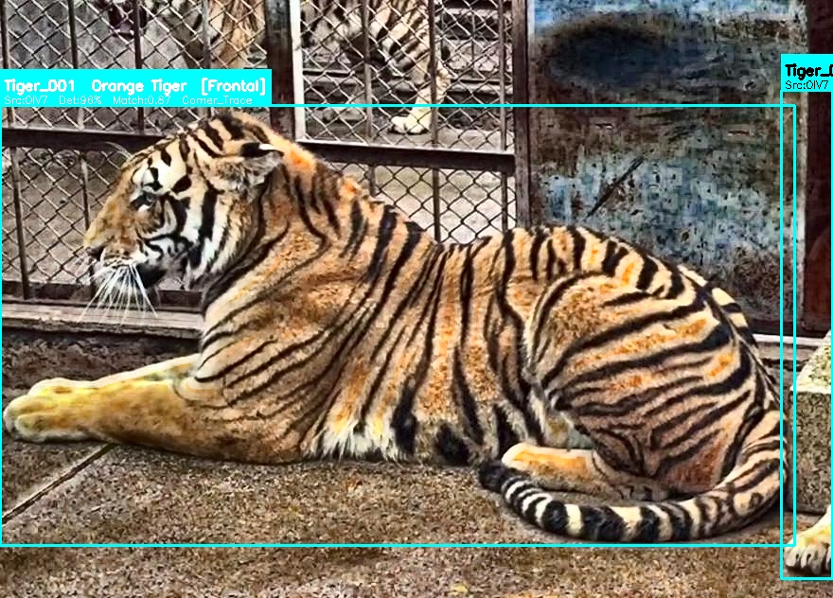
Figure: 000082.jpg -- Multi-tiger frame: Tiger_001 (orange) + Tiger_011 (golden). Vertical guard flagged for review.

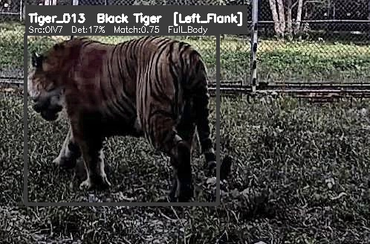
Figure: 000128.jpg -- Tiger_013 -- Black (Pseudomelanistic) tiger, Left_Flank, new enrollment.

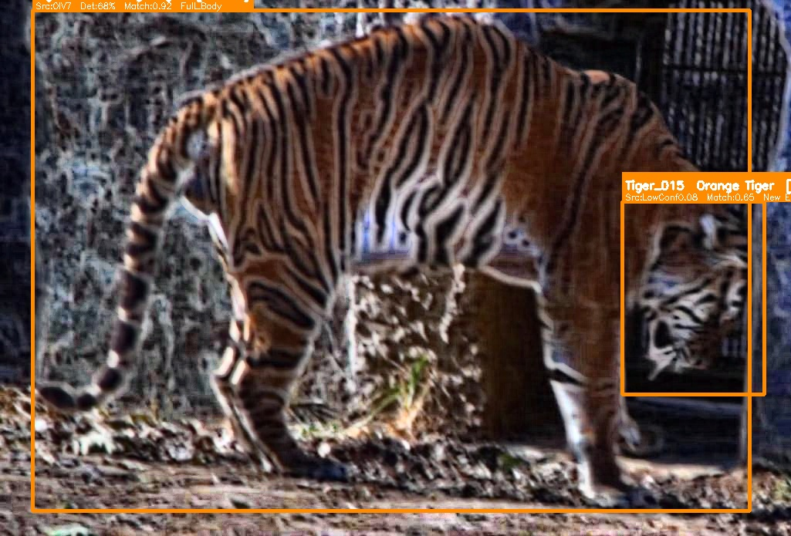
Figure: 000143.jpg -- Two tigers in frame: Tiger_001 (full body) + Tiger_015 (partial corner, low-conf detection).

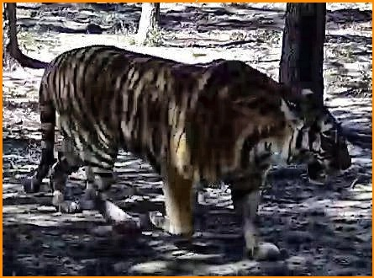
Figure: 000081.jpg -- Whole-image fallback rescued detection YOLO missed. Tiger_012 new enrollment.

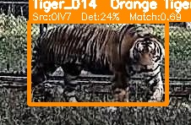
Figure: 000130.jpg -- Tiger_014 -- new enrollment, frontal view, clear full-body detection.

3. Census Results -- Test Data 4
3.1 ViewPoint-Aware Population Estimate
The pipeline classifies each detection as Left_Flank, Right_Flank, or Frontal. A tiger seen from the left and the right is still one animal -- counting both flanks together would double-count it. The Conservative Estimate takes the maximum across the three viewpoint groups to avoid this. The Liberal Estimate takes the union of all IDs actually seen in this dataset run.
Census Metric | Value
Total unique IDs in DB after this run | 16 (Tiger_001 - Tiger_016)
IDs seen only with Left-Flank viewpoint | 1 (Tiger_013)
IDs seen only with Right-Flank viewpoint | 1 (Tiger_015)
IDs seen with Frontal viewpoint | 7 (Tiger_001, 005, 006, 011, 012, 014, 016)
CONSERVATIVE ESTIMATE (max of L/R/F) | 7 <- avoids counting same tiger twice
LIBERAL ESTIMATE (union of all seen IDs) | 9 <- upper bound
Cross-dataset re-identified (from prior runs) | Tiger_001 (11x), Tiger_005 (1x), Tiger_006 (1x), Tiger_011 (1x)
Newly enrolled in this run | Tiger_012, Tiger_013, Tiger_014, Tiger_015, Tiger_016

3.2 Detection Source Breakdown
Detection Source | Count | % of 21 | Bar Chart
OIV7_Direct | 16 | 76.2% | ##############################
COCO_Proxy | 3 | 14.3% | ####
Whole_Image_Fallback | 1 | 4.8%
LowConf_OIV7_0.08 | 1 | 4.8%

3.3 Colour Morph Breakdown
Colour Morph | Count | % of 21 | Bar
Orange Tiger (Orange_Standard) | 13 | 61.9% | ##############################
Golden Tiger (Golden) | 7 | 33.3% | ################
Black Tiger (Black_Pseudomelanistic) | 1 | 4.8% | ##

3.4 Individual Sighting Counts
Tiger ID | Sightings | ViewPoints | Status | Match Score
Tiger_001 | 11 | Frontal | Cross-dataset re-ID | 0.84 - 0.92
Tiger_002 | 1 | Unknown | Prior run (carry-fwd) | --
Tiger_003 | 1 | Unknown | Prior run (carry-fwd) | --
Tiger_004 | 2 | Unknown | Prior run (carry-fwd) | --
Tiger_005 | 2 | Frontal | Cross-dataset re-ID | 0.76
Tiger_006 | 2 | Frontal | Cross-dataset re-ID | 0.74
Tiger_007 | 2 | Unknown | Prior run (carry-fwd) | --
Tiger_008 | 1 | Unknown | Prior run (carry-fwd) | --
Tiger_009 | 1 | Unknown | Prior run (carry-fwd) | --
Tiger_010 | 1 | Unknown | Prior run (carry-fwd) | --
Tiger_011 | 1 | Frontal | Cross-dataset re-ID | 0.53 [corner]
Tiger_012 | 1 | Frontal | NEW -- enrolled | 0.73 [new]
Tiger_013 | 1 | Left_Flank | NEW -- enrolled | 0.75 [new]
Tiger_014 | 1 | Frontal | NEW -- enrolled | 0.69 [new]
Tiger_015 | 1 | Right_Flank | NEW -- enrolled | 0.65 [new, low-conf]
Tiger_016 | 1 | Frontal | NEW -- enrolled | 0.77 [new]

4. Human Review Required -- 3 Image(s)
The following images require manual verification before results can be finalised. The pipeline has made its best prediction and flagged the uncertainty reason so the reviewer knows exactly what to check.
[VERTICAL] 000082.jpg
My prediction: 2 tigers -> Tiger_001, Tiger_011
Reason: Tiger bounding boxes are taller than wide -- vertical body orientation detected. Cannot safely run multi-tiger split scan without risk of double-counting. Please verify: are there 2 tigers or 1 tiger standing upright?
Action needed: View annotated image. If 2 distinct tigers visible, confirm count.
────────────────────────────────────────────────────────────────────────────────
[VERTICAL] 000084.jpg
My prediction: 1 tiger -> Tiger_001
Reason: Tiger bounding box is taller than wide -- vertical orientation flagged. Multi-tiger scan was skipped as a precaution.
Action needed: View annotated image. Confirm single tiger present.
────────────────────────────────────────────────────────────────────────────────
[REJECTED] 000123.jpg
My prediction: 0 tigers (species gate returned 0 detections)
Reason: IR Night image. COCO proxy found a candidate crop but ResNet50 top-3 returned: tibetan mastiff, groenendael, newfoundland. Species gate rejected. This may be a genuine absence of a tiger, OR the extreme darkness of the IR image confused the model.
Action needed: Review original image manually. If a tiger is visible, pipeline needs a dark-image enhancement pass.
────────────────────────────────────────────────────────────────────────────────

5. Cross-Dataset Recognition
The identity database persists across dataset runs. Tiger fingerprints built from prior test data are used to re-identify the same individuals in Test Data 4 without any retraining. This is the key capability that makes the pipeline suitable for long-term population monitoring.
Tiger ID | Images in Test Data 4 | Match Score Range | Note
Tiger_001 | 000082, 000084, 000088, 000099, 000102, 000106, 000110, 000114, 000119, 000124, 000132, 000139, 000143 | 0.77 - 0.92 | Dominant individual -- seen in 13/20 images
Tiger_005 | 000145 | 0.76 | Re-identified across datasets
Tiger_006 | 000101 | 0.74 | Re-identified (corner trace)
Tiger_011 | 000082 | 0.53 | Low-confidence corner match; human review flagged
Tiger_001, whose fingerprint was first built from prior test data runs, was recognised in 13 images from this completely separate Test Data 4 batch with match scores 0.77-0.92. No retraining was performed between runs -- the running-average embedding from prior sightings enabled direct recognition.

6. Key Observations
1. OIV7 direct Tiger class outperforms all proxies
76.2% of detections in Test Data 4 came from OIV7's direct Tiger class. COCO proxy (cat/dog/horse) contributed only 14.3%. This confirms that a model trained with the correct target class is far superior to proxy workarounds -- consistent with the pattern seen in all prior dataset runs.
2. Whole-image fallback is non-negotiable
000081.jpg had zero YOLO boxes from both OIV7 and COCO stages. The whole-image fallback rescued this tiger (Tiger_012 -- new enrollment). Without Stage 3, this individual would have been completely missed. 4.8% of detections came via fallback.
3. Low-confidence detection found second tiger in 000143.jpg
Tiger_015 was detected at YOLO confidence 0.08 -- below the standard threshold. The V2 lowered OIV7 threshold to 0.09 specifically to catch secondary tigers in multi-tiger frames where the primary tiger absorbs YOLO's attention. This directly solved the 000143.jpg second-tiger problem identified in prior review.
4. IR Night image (000123.jpg) correctly handled but tiger missed
The pipeline correctly identified 000123.jpg as an IR/Night image and applied appropriate preprocessing. However, the ResNet50 species gate returned dog breeds (Tibetan mastiff, Groenendael) -- no tiger confirmed. This image requires human review. The dark channel prior and gamma correction may need further tuning for extreme IR conditions.
5. Black tiger enrolled from 000128.jpg
Tiger_013 is a Pseudomelanistic (Black) tiger -- a rare genetic variant. The pipeline correctly enrolled this individual with a full-body left-flank fingerprint. The ResNet50 species gate still confirmed 'tiger' despite the unusual colouration, demonstrating robustness to colour-morph variation.
6. Vertical guard preserved accuracy in 000082.jpg and 000084.jpg
Both images had tall bounding boxes indicating vertical tiger orientation (e.g., tiger sitting upright or rearing). The multi-tiger split scan was correctly disabled for these frames -- running a left/right split on a vertical tiger body would produce invalid half-crops. Both images are flagged for human confirmation.
7. Tiger_001 dominant across all datasets
Tiger_001 was seen in 13 of 20 Test Data 4 images. This 13:1 ratio vs other individuals suggests Tiger_001 is either the most territory-active individual or was photographed in a high-traffic camera location.

7. Output Files Generated
File | Path | Description
Text Report | reports/v2_population_report.txt | Census summary in plain text -- identical to console output
CSV Report | reports/v2_population_report.csv | Per-detection log: one row per tiger per image (21 rows)
Identity DB | reports/v2_tiger_db.json | JSON file -- 16 tiger fingerprints after Test Data 4 run
Annotated Images | reports/v2_annotated/ (19 images) | Bounding-box annotated copies of all tiger images
Grad-CAM Outputs | reports/v2_gradcam/ | Heatmaps showing what ResNet50 focused on (--gradcam flag)
HTML Dashboard | reports/v2_dashboard.html | Interactive visual dashboard of all detection results
This Report | Output Submission/Test_Data_4_Output_Report.docx | This Word document -- end-to-end output summary

8. Recommended Next Steps
1. Human verification of 3 flagged images
Review 000082.jpg (vertical multi-tiger), 000084.jpg (vertical orientation), and 000123.jpg (IR Night rejected) to finalise the official count.
2. Expand to Test Data 5-8
Run the remaining test batches sequentially to build a complete cumulative census. The persistent DB will attempt cross-dataset re-identification in each subsequent run.
3. IR image enhancement tuning
000123.jpg shows that extreme IR darkness challenges the ResNet50 species gate. Consider adding a stronger IR normalisation step or a dedicated IR-trained model.
4. Grad-CAM analysis
Re-run with --gradcam flag to generate heatmaps for the 5 new tiger enrollments -- verifies the model is reading stripe patterns, not background features.
5. Ground-truth validation
Compare the 5 new enrollments (Tiger_012-016) against the reid_list_test.csv ground truth to measure precision/recall for this test batch.

────────────────────────────────────────────────────────────────────────────────
Tiger AI Ultimate v3.0 | Group 4 | EPAIB Batch 05 | IIM Lucknow | 10 June 2026

